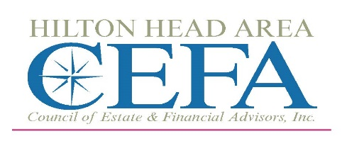
Sponsorship Opportunities for 2023-2024 Election Form
PLATINUM SPONSOR $1000
- Exclusive Holiday Party Sponsor, Westin Hotel
- A Sponsor of 4 council meetings
- Recognition by President at 4 events
- Logo at Podium at all events
- Signage at entrance of all events, and president’s table
- Signage at food and bar areas of all events
- May provide giveaways/door prizes at all events
- VIP President’s table for 4 guests at holiday event including signage
- VIP President’s table at 4 council meetings including 2 guests and signage
- Listed as the Platinum Sponsor on our Website’s Sponsorship page for 12 months
- Hi-lighted on website banner for 12 months
- Included in Photos on website for 12 months
- Hi-lighted in e-article each publication
- First Right of Refusal Next Year

SCHOLARSHIP SPONSOR $1000
GOLD SPONSOR $ 750
- A Sponsor of 3 council meetings
- Recognition by President at 3 events
- Logo at podium at 3 events
- Signage at entrance of all events
- May provide giveaways/door prizes
- VIP President’s table for 2 guests at 2 events including signage
- Listed as a Gold Sponsor on our Website’s Sponsorship page for 12 months
- Included in photos on website for 6 months
- Hi-lighted in e-article for 6 months

SILVER SPONSOR $ 500
- A Sponsor of 2 council meetings
- Recognition by President at 2 events
- Signage at entrance of 2 events
- May provide giveaways/door prizes
- VIP President’s table for 2 guests at 2 events including signage
- Listed as a Silver Sponsor on our Website’s Sponsorship page for 12 months
- Included in Photos on website for 3 months
- Hi-lighted in e-article up to 3 times

BRONZE (BAR AREA) $ 250
- A Sponsor of 1 council meeting
- Recognition by President at 1 event
- Sponsor signage at bar area
- Listed as a Bar Sponsor on our Website’s Sponsorship page for 12 months
- Included in photos on website
- Hi-lighted in e-article

Please note: All logo items and giveaways must be provided by Sponsor and approved by CEFA before use.

